Special Educational Needs and Disabilities (SEND) Information Report

West Borough Primary School


SENCO:

Mrs Gemma Jury-Sofi
Contact No: 01622-726391
senco@west-borough.kent.sch.uk

SEND Governor:

Mrs Clare Chater

Last reviewed on: | 31/10/2025
Next review due by: | 31/10/2026

Contents
1. What types of SEND does the school provide for? 3
2. Which staff will support my child, and what are their key responsibilities? 5
3. What should I do if I think my child has SEND? 6
4. PINS Project 7
5. What happens if the school identifies a need? 8
6. How will the school measure my child’s progress? 9
7. How will I be involved in decisions made about my child’s education? 10
8. How will my child be involved in decisions made about their education? 11
10. How will the school evaluate whether the support in place is helping my child? 12
11. How will the school ensure my child has appropriate resources? 13
12. How will the school make sure my child is included in activities alongside pupils who don’t have SEND? 13
13. How does the school make sure the admissions process is fair for pupils with SEN or a disability? 14
14. How does the school support pupils with disabilities? 14
15. How will the school support my child’s mental health and emotional and social development? 15
16. What support is in place for looked-after and previously looked-after children with SEND? 15
17. What support will be available for my child as they transition between classes or settings? 15
18. What support is available for me and my family? 17
19. What should I do if I have a complaint about my child’s SEND support? 18
20. Supporting documents 19
21. Glossary 19

Dear parents and carers,
The aim of this Information Report is to explain how we implement our SEND policy. In other words, we want to show you how SEND support works in our school.
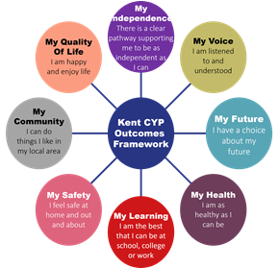
As educational professionals, we are all working towards the ultimate goal of growing independent young people as they prepare for adulthood. All provision and support we provide is working towards achieving the Kent Children and Young People (CYP) Outcomes Framework:

If you want to know more about our arrangements for SEND, read our SEND policy alongside this Information Report. You can find our SEND policy on our website.

Please note: If there are any terms we’ve used in this information report that you’re unsure of, you can look them up in the glossary at the end of the report.

1. What types of SEND does the school provide for?

Our school provides for pupils with the following needs (as outlined in the SEND Code of Practice 2015):
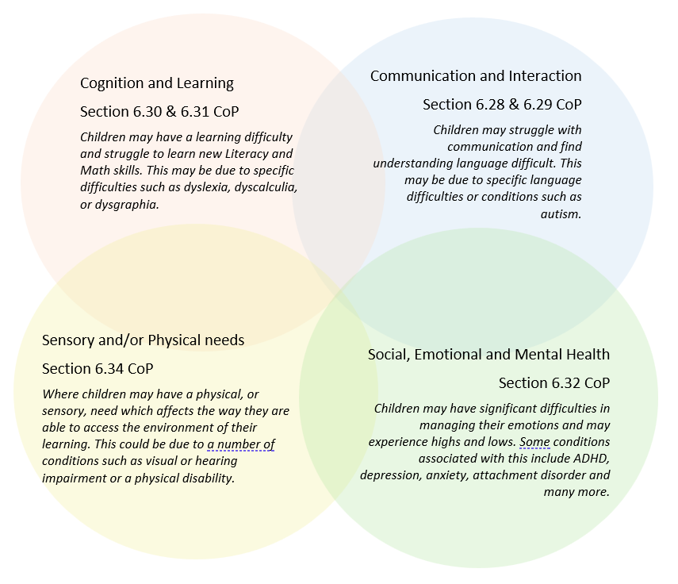

Often you will find that children’s needs overlap and are rarely confined to one area of need, which is why it is important to gain a wholistic overview of your child.
More information about the Areas of Need can be found in the Special educational needs and disability code of practice: 0 to 25 years (link below).
SEND_Code_of_Practice_January_2015.pdf (publishing.service.gov.uk)

2. Which staff will support my child, and what are their key responsibilities?
At West Borough Primary School, all staff are considered responsible for supporting the needs of pupils with SEND. Our staff are committed to regular, high-quality training to ensure that they have the knowledge and skills to better meet a wide range of pupil needs.
Below outlines key staff who will be supporting your child. Please note that this list is not exhaustive.
SENCo: Mrs. Jury-Sofi has overall responsibility for the SEND provision in our school. She is a qualified teacher and holds the NASENCO qualification. Mrs. Jury-Sofi undergoes continuing professional development to enhance her own knowledge of SEND, which can then be disseminated to other staff members as appropriate. She is supported by the follwing staff.

Mrs Jury-Sofi Mrs Parris Mrs Burtwell Mrs England Miss Berry
(SENCo) (SENCo Assistant) (FLO) (Nurture) (ELSA)

Class Teams: All classes at West Borough Primary School have a qualified teacher and at least one teaching assistant. We are committed to developing the ongoing expertise of all our staff. Both in-house and external training opportunities are provided for all staff to enhance their skills and knowledge in the delivery of Quality First Teaching, evidence-based interventions and in areas of specific SEND need, including social, emotional & mental health needs. Our teaching assistants are trained to deliver a range of interventions to support children’s academic, social and emotional progress. Training opportunities offered to staff throughout the year will be linked to the needs of the current cohort of children.

External Agencies: Sometimes we need extra help to offer our pupils the support that they need. Whenever necessary we will work with external support services to meet the needs of our pupils with SEND and to support their families. These may include:

- Child and adolescent mental health services (CAMHS)
- Education welfare officers
- Educational psychologists
- GPs or paediatricians
- NELFT practitioners
- Occupational therapists
- Therapeutic practitioners
- School Liaison Officer
- School nurses
- SEND Inclusion Advisor
- Specialist Teaching Service
- Speech and language therapists
- Educational Psychologists
Safeguarding services



3. What should I do if I think my child has SEND?
At West Borough Primary School, we aim to identify and assess the needs of all pupils as soon as possible, in order to ensure early identification and intervention for any SEND and to support the pupil in making good progress. Underpinning all our provision in school is the graduated approach cycle of: Assess, Plan, Do and Review.
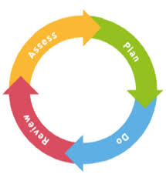
If you have concerns about your child, the following process will be followed:
Phase 1 | If you think that your child might have SEND, please raise your concerns with the school, so that the SENCO is aware. In the first instance, please speak to the class teacher, who will be able to explain any strategies and/or interventions that might already be in place to support your child. Alternatively, please speak directly with the SENCO.
Phase 2 | We will meet with you to discuss your concerns and try to get a better understanding of what your child’s strengths and difficulties are. Together we will decide what outcomes to seek for your child and agree on next steps. We will make a note of what has been discussed and add this to your child’s record.
Phase 3 | We will implement agreed strategies and monitor them over an agreed period. These are likely to be universal strategies set out in the mainstream core standards. A copy of this can be found here: https://www.kelsi.org.uk/__data/assets/pdf_file/0005/117257/Specialeducational-needs-mainstream-core-standards-guide-for-parents.pdf
Phase 4 | If we decide that your child needs SEND support, we will formally notify you and your child will be added to the school’s SEND register. They will receive additional support, and this will be reviewed using the assess, plan, do, and review model. This will initiate the ‘Graduated Approach.’

4. PINS Project

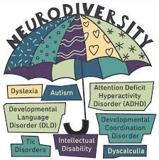
We are excited to be part of the PINS project. PINS stands for ‘Partnerships for Inclusion of Neurodiversity in Schools’. It is a project that helps schools improve the experience of children who are neurodivergent so that they feel welcomed, supported and able to take part in all aspects of school life. PINS is a national initiative led by the Department for Education and NHS England.

How can PINS help my child?
PINS might help your child by improving their school environment and helping schools adapt the way they do things to meet your child’s needs (which could include mental health, speech and language and physical and sensory) to help them learn and take part in all aspects of school life. PINS can help all pupils in school – children don’t need a formal diagnosis to benefit from this project.
How can PINS help parents?
PINS aims to help parents build stronger relationships and improve communication with their child’s school. Parents’ views and experiences are a vital part of this project. Kent PACT (Parents and Carers Together – the local parent/carer forum) will hold forums like coffee mornings and other events for parents so that they can share their feedback, knowledge and ideas with other parents and their child’s school. By working together, parents/carers and schools can support each other to give children the best experiences of school.


5. What happens if the school identifies a need?
A similar process is followed if a concern is raised by the school.
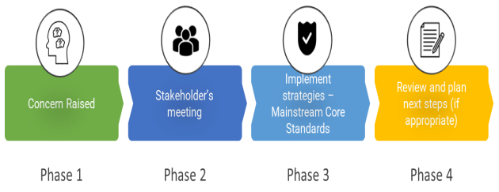
All of our class teachers are responsible for the monitoring of pupils who have been identified as having SEND. They also review those who are not making the expected level of progress in their schoolwork or socially.
If the teacher notices that a pupil is having difficulties, they try to find out if the pupil has any gaps in their learning. If they can find a gap, the school will provide appropriate support. Pupils who don’t have SEND usually make progress quickly once the gap in their learning has been filled.
If the pupil is still finding it difficult to make the expected progress, the teacher will talk to the SENCO and will contact you to discuss the possibility that your child has SEND.

6. How will the school measure my child’s progress?
We have rigorous monitoring in place to track the progress all our pupils make in all areas of the curriculum. Our staff are vigilant at supporting and raising any concerns. We use data tracking, assessments, and classroom observations to identify additional needs and celebrate achievements. Pupil Progress Meetings, attended by the class teacher and members of the senior leadership team, are held throughout the year to allow for lengthy discussions regarding children the class teachers are concerned about.
Parents and carers are invited into school for both formal and informal meetings. TLC’s (The Learning Conferences) are held twice a year, and a formal report is written at the end of each academic year. If your child has a personalised plan, these will be reviewed regularly, and meetings will be held to discuss progress.
We will follow the ‘graduated approach’ to meeting your child’s SEND needs.
The graduated approach is a 4-part cycle of assess, plan, do, review.
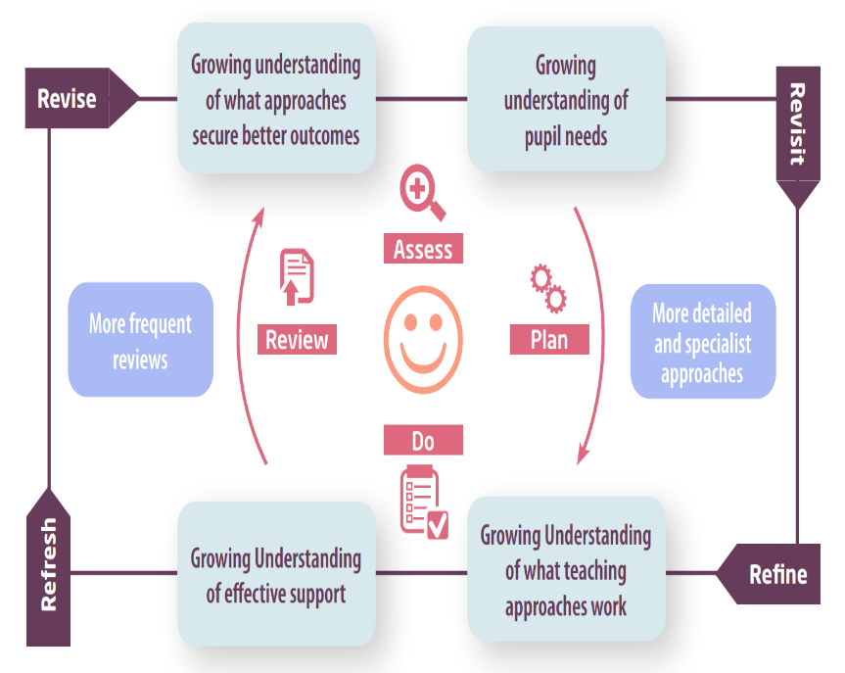

Assess | If your child is not making the expected level of progress, we will make an assessment to find out what strengths and difficulties your child has. We will ask for you and your child’s input, as well as getting help from external professionals where necessary.
Plan | In discussion with you and your child, we will decide what outcomes we are hoping to achieve. We will make a plan of the support we will offer your child to help them meet those outcomes. We will make a record of this and share it with you and all relevant school staff.
Do | We will put our plan into practice.  The class teacher, with the support of the SENCO, will be responsible for working with your child on a daily basis, and making sure the support we put in place is having the impact we intended.
Review | We will assess how well the support we put in place helped the pupil to meet the outcomes we set. We will use our improved understanding of your child’s needs to improve the support we offer; this may mean the Plan, Assess, Do, Review cycle continues.

7. How will I be involved in decisions made about my child’s education?
At West Borough Primary School, we value strong home-school communication and have a range of procedures in place to facilitate this:
- An “open door” policy which encourages parents and carers to make appointments to see or speak with a member of staff if they have any concerns about their child’s academic progress or social and emotional wellbeing.
- Formal parent consultations twice a year with the class teacher; the SENCo might also attend these meetings alongside the class teacher if appropriate
- A written report outlining children’s academic progress once per year
- Newsletters, emails to parents / carers and information on our website or via Class Dojo
- Contact with the class teacher via Class Dojo
- Personalised Plans which are reviewed three times a year.
- Annual reviews for children with EHCPs
- Additional meetings with the SENCo and, where appropriate, specialist services to support parents and carers in working with children at home
If you have concerns that arise between these meetings, please contact Mrs Jury-Sofi via the school office or via email : senco@west-borough.ent.sch.uk

8. How will my child be involved in decisions made about their education?
The level of involvement will depend on your child’s age and individual needs. We recognise that no two pupils are the same, so we will decide on a case-by-case basis.
- We will provide annual reports on your child's progress.
- A member of staff who knows your child well will meet you twice a year
- Set clear outcomes for your child’s progress
- Review progress towards those outcomes
- Discuss the support we will put in place to help your child make that progress
- Identify what we will do, what we will ask you to do, and what we will ask your child to do


9. How will the school adapt teaching to suit my child?
Adaptive teaching is embedded in our curriculum and practice; this may be in the form of additional support, manipulatives, additional resources, scaffolding of tasks, differentiated success criteria, and differentiated questions. Teachers and Leaders use the Kent Mainstream Core Standards to support the inclusion of all pupils.
All pupils, regardless of need, access high quality class teaching. Class teachers plan and deliver an adapted curriculum which considers the pupils’ individual strengths and areas of need and reasonable adjustments are made to the classroom environment. Regular reviews and monitoring by the leadership team ensure that this is in place. A combination of visual, auditory, and kinesthetic teaching approaches is used in the classroom.
When we receive reports from professionals with recommendations, we will take these into consideration when implementing supportive adaptations for pupils.
Where physical adaptations to the learning environment are required, the school may work with external agencies such as Occupational Therapy and STLS to make changes, so that our learning environment is accessible to all. Where a child requires further support, the school uses the graduated approach to plan and deliver appropriate interventions for the child. Your child’s teacher is responsible and accountable for the progress and development of all the pupils in their class.
High-quality teaching is our first step in responding to your child’s needs. We will make sure that your child has access to a broad and balanced curriculum in every year they are at our school.
We will adapt our approaches to how we teach to suit the way the pupil works best. There is no 'one size fits all’ approach to adapting the curriculum, we work on a case-by case basis to make sure the adaptations we make are meaningful to your child and are guided by the Mainstream Core Standards in the first instance.
These adaptations might include (but are not limited to):
- Adapting our approaches, for example, giving longer processing times, pre-teaching of key vocabulary, reading instructions aloud, etc.
- Adapting our resources and staffing
- Using recommended aids, such as laptops, coloured overlays, visual timetables, larger font, etc.
- Teaching assistants or support staff will support pupils appropriately depending on their presentation of need
- Scaffolding lesson materials

10. How will the school evaluate whether the support in place is helping my child?
West Borough Primary School has a robust self-assessment system in place which includes learning walks, lesson observations, book looks and pupil voice interviews, all of which include monitoring provision for pupils with SEND.
Interventions are regularly discussed with class teachers. Appropriate targets are set for all children, and these are regularly reviewed. All interventions, and the impact of these, are monitored by the SENCO. The effectiveness of EHCP provision is further evaluated and discussed during EHCP Annual Review Meetings.
All adaptations and interventions are closely monitored and are adapted regularly to reflect children’s progress and evolving areas of need. The SENCO oversees all additional support.
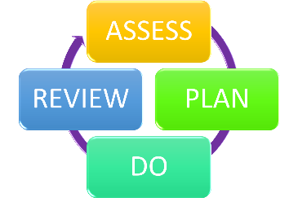
We will evaluate the effectiveness of provision for your child by:
- Reviewing their progress towards their goals each term
- Frequently reviewing the impact of interventions
- Using pupil questionnaires
- Monitoring by the SENCO
- Using provision maps to measure progress
- Holding an annual review (if they have an education, health and care (EHC) plan)

11. How will the school ensure my child has appropriate resources?
It may be that your child’s needs mean we need to provide additional resources such as:
- Additional resources to support their learning.
- Adaptations to class support
- Further training for our staff
- External specialist expertise

If the situation arises whereby a child requires specialist expertise, the school will work with the Local Inclusion Forum Team (LIFT) to identify and allocate the most suitable specialist teacher within the area. In addition to this, the school can seek advice from other available support services including speech and language therapists, mental health support, occupational therapy, and school nurses. Where a child requires extensive additional support, the school may make referrals to specialist services for them to work directly with the child and family.

12. How will the school make sure my child is included in activities alongside pupils who don’t have SEND?
West Borough Primary School has an inclusive approach to all aspects of the curriculum, including activities outside the classroom. All children, regardless of need, are encouraged to participate in all aspects of school life. Where there are concerns regarding safety of a child with SEND or regarding the ability of a child to engage with an activity as a result of identified SEND, parents and carers are consulted and involved in additional planning so adaptations can be made to allow them to participate. Individual risk assessments can be put in place to support this process and specialist services may be consulted. We have an accessibility plan which further details how we ensure children with SEND are included in daily school life.
All our extra-curricular activities and school visits are available to all our pupils, including our before and after-school clubs.
No pupil will be excluded from taking part in these activities because of their SEN or disability and we will make whatever reasonable adjustments are needed to make sure that they can be included.

13. How does the school make sure the admissions process is fair for pupils with SEN or a disability?
West Borough’s admissions policy outlines our processes and oversubscription criteria which apply to all children seeking West Borough Primary School. If a child has an EHCP and the school is named as the most appropriate school, priority for admission will be given to that child. If your child has SEND and you are considering us as a school placement, you are welcome to contact the SENCO to discuss how they would be supported. We may also arrange additional transition information and tours of the school if appropriate.
Please see our Admissions Policy, which can be found on our website.

14. How does the school support pupils with disabilities?
You are considered to be disabled under the Equality Act 2010 if you have a physical or mental impairment that has a ‘substantial’ and ‘long-term’ negative effect on your ability to do normal daily activities.
West Borough Primary School has an inclusive approach to all aspects of the curriculum. All children, regardless of need, are encouraged to participate in all aspects of school life. Our staff are trained in a variety of communication techniques including Makaton, and the use of Widgit symbols where appropriate.
Where further physical adaptations to the learning environment are required, the school will work with external agencies such as Occupational Therapy and STLS to make reasonable adjustments to our learning environment is accessible to all.

15. How will the school support my child’s mental health and emotional and social development?
We pride ourselves in being a caring, understanding staff who look after our children, parents and carers. As such, we seek to offer a wide range of pastoral support to ensure children’s social and emotional development.
Pupil Progress Meetings are held twice a year. These meetings include discussions about children’s wellbeing as well as their academic achievement. Interventions can enhance children’s social and emotional development and are also included where appropriate. Training is offered to staff to improve their knowledge of the social and emotional barriers that a child might have and to improve their ability to provide targeted support for these. We have a dedicated nurture team who provide targeted social and emotional support for identified pupils. We also have a FLO, who works closely with families.
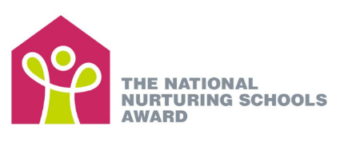
We are working towards gaining our National Nurturing Award this year. One of our Nurture practitioners is also working towards becoming a trained Emotional Literacy Support Assistant (ELSA) practitioner.

16. What support is in place for looked-after and previously looked-after children with SEND?
Mrs Jury-Sofi is our Designated Teacher for looked-after and previously looked-after children. She will work to make sure all teachers understand how a looked-after or previously looked-after pupil’s circumstances and their SEND might interact, and what the implications are for teaching and learning. Pupils who are looked-after or previously looked-after will be supported much in the same way as any other child who has SEND. However, looked-after pupils will also have a personal education plan (PEP). We will make sure that the PEP and any SEND support plans or EHC plans are consistent and complement one another.

17. What support will be available for my child as they transition between classes or settings?
At West Borough Primary School, we understand that some children find transitions particularly challenging and will need extra support to manage them successfully. As part of our inclusive practice, we complete Home Visits for all children that join our Nursery or Reception classes. This is to help staff to get to know the family in a familiar environment before they join us.

Joining from another setting:
• When a child is moving from a pre-school setting to our reception classes, all parents and carers are invited to attend a welcome meeting with the Headteacher.
• Where a child has an identified SEND need or parents and carers have concerns about a potential SEND need, they are encouraged to make an appointment with the SENCO prior to starting.
• A phased start supports our Year R children when they join school
• Additional transition support can be arranged for children with SEND including attendance at nursery annual reviews, additional visits to West Borough Primary School and observations of the child within their pre-school setting.
• When a pupil joins us part-way through their school journey, we liaise closely with staff at their previous setting to ensure all relevant paperwork is passed on and all needs are discussed and understood.
• Where there is identified SEND, we will liaise with previous settings and, where appropriate professionals, to ensure relevant support is in place as soon as the child starts with us.

Moving into a new year group:
Detailed handover meetings take place when children move to a new year group, including discussions with the SENCO, to ensure relevant interventions and support are in place as soon as they begin in their new year group.

Leaving to join a new school:
When a child leaves us part-way through their school journey, we liaise closely with staff at their new setting, so all relevant paperwork is passed on and all needs are discussed and understood.

Between phases (for secondary schools):

The SENCO and the FLO will attend the SEND transition event organised by STLS to meet with Secondary School to pass on relevant information so that they can prepare accordingly. All relevant paperwork regarding the pupil’s special educational needs or disability will be transferred to the new educational setting. Pupils are prepared for transitions in a timely manner and as a school we follow the 13-week programme from the STLS team.

18. What support is available for me and my family?
If you have questions regarding SEND, please get in touch and let us know. We want to support you, your child and your family.
To see what support is available to you locally, have a look at Kent’s Local Offer. Kent publishes information on their website.
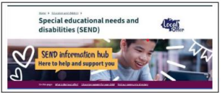
https://www.kent.gov.uk/education-and-children/special-educational-needs/about-the-send-local-offer

Our local special educational needs and disabilities information advice and support services (SENDIASS) organisations are:
https://www.kent.gov.uk/education-and-children/special-educational-needs/listening-to-your-voice-and-taking-action/Information-Advice-and-Support-Kent

Local charities that offer information and support to families of pupils with SEND are:
National charities that offer information and support to families of pupils with SEND are:
- IPSEA
- SEND family support
- NSPCC
- Family Action
- Special Needs Jungle

19. What should I do if I have a complaint about my child’s SEND support?
Complaints about SEND provision in our school should be made to the class teacher in the first instance. If your concerns have not been addressed to your satisfaction, please contact the SENCO, Mrs. Jury-Sofi, where a meeting will be arranged to discuss your concerns further.
If you feel that the situation is still unresolved, we would invite you to email the school office, where you will be able to arrange a meeting with the headteacher, Mrs Edinburgh.
For our full complaints procedure, please refer to the school’s complaints policy.
If you are not satisfied with the school’s response, you can escalate the complaint. In some circumstances, this right also applies to the pupil themselves.
To see a full explanation of suitable avenues for complaint, see pages 246 and 247 of the SEND Code of Practice.
If you feel that our school discriminated against your child because of their SEND, you have the right to make a discrimination claim to the first-tier SEND tribunal. To find out how to make such a claim, you should visit: https://www.gov.uk/complain-about-school/disability-discrimination
You can make a claim about alleged discrimination regarding:
- Admission
- Exclusion
- Provision of education and associated services
- Making reasonable adjustments, including the provision of auxiliary aids and services
Before going to a SEND tribunal, you can go through processes called disagreement resolution or mediation, where you try to resolve your disagreement before it reaches the tribunal. Please ask the SENCO if you require this information.

20. Supporting documents

- Equality Policy
- Child protection and safeguarding policy
- Behaviour Policy
- Anti-bullying Policy
- Attendance policy
- SEND policy
- SEN & Disabilities Code of Practice 2015
- Mainstream Core Standards

21. Glossary
- Access arrangements – special arrangements to allow pupils with SEND to access assessments or exams
- Annual review – an annual meeting to review the provision in a pupil’s EHC plan
- Area of need – the 4 areas of need describe different types of needs a pupil with SEND can have. The 4 areas are communication and interaction; cognition and learning; physical and/or sensory; and social, emotional and mental health needs.
- CAMHS – child and adolescent mental health services
- Differentiation – when teachers adapt how they teach in response to a pupil’s needs
- EHC needs assessment – the needs assessment is the first step on the way to securing an EHC plan. The local authority will do an assessment to decide whether a child needs an EHC plan.
- EHC plan – an education, health and care plan is a legally-binding document that sets out a child’s needs and the provision that will be put in place to meet their needs.
- First-tier tribunal/SEND tribunal – a court where you can appeal against the local authority’s decisions about EHC needs assessments or plans and against discrimination by a school or local authority due to SEND
- Graduated approach – an approach to providing SEND support in which the school provides support in successive cycles of assessing the pupil’s needs, planning the provision, implementing the plan, and reviewing the impact of the action on the pupil
- Intervention – a short-term, targeted approach to teaching a pupil with a specific outcome in mind
- Local offer – information provided by the local authority which explains what services and support are on offer for pupils with SEND in the local area
- Outcome – target for improvement for pupils with SEND. These targets don't necessarily have to be related to academic attainment
- Reasonable adjustments – changes that the school must make to remove or reduce any disadvantages caused by a child’s disability
- SENCO – the special educational needs co-ordinator
- SEN – special educational needs
- SEND – special educational needs and disabilities
- SEND Code of Practice – the statutory guidance that schools must follow to support pupils with SEND
- SEND information report – a report that schools must publish on their website, that explains how the school supports pupils with SEND
- SEND support – special educational provision which meets the needs of pupils with SEND
- Transition – when a pupil moves between years, phases, schools or institutions or life stages

‘Be kind, be safe, be responsible and embrace challenge’

